## System Design and instructions for ROBIL members

1. **Definitions**

* Event (E) – one of 8 Darpa’s defined scenarios
* Mission- sub phase of an event
* Task (T) – one of 7 groups defined in the proposal
* Capability- module which is under the responsibility of one Task. However, capability might request for information/function from other capabilities which are not under the same task.

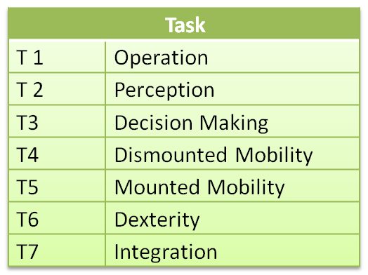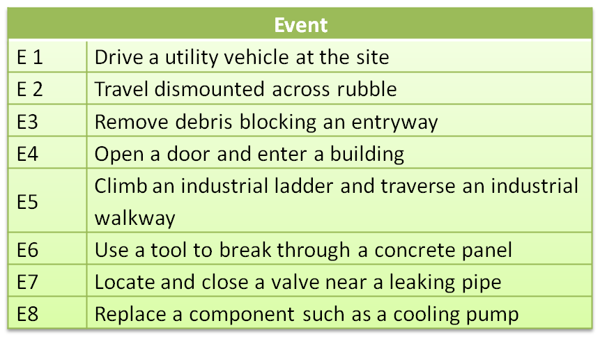

1. **Capabilities allocation for tasks:**

|  |  |  |  |
| --- | --- | --- | --- |
| Task | Symbol (Cij) | Capability Name | Description |
| T1 Operation | **C11** | Operator control | Event execution, Intervention in mission planning and execution (T3) processes. |
| T2 Perception | **C21** | Vision and Lidar | Operate camera and Lidar to capture scene at a requested azimuth. Process image and provide 3D reconstruction of scene. |
| **C22** | Ground recognition and mapping | get ground position and surface shape |
| **C23** | Object recognition | Search for a specific object in an image |
| **C24** | Obstacle Detection | Detect obstacles on ground and above ground |
| **C25** | Global Position | Find robot’s position in world coordinates |
| T3  Decision-Making | **C31** | Global Path Planning | Search for a global route on a map |
| **C32** | Local Path Planning | Find local path using sensed environment |
| **C33** | Mission planning | Plan how to complete mission (such as open a door, replace pump etc.) |
| **C34** | Mission execution | execute mission planning by sequencer |
| T4  Dismounted mobility | **C41** | Body Control | Move arms, legs, head or body (all joints except fingers) by demand. |
| **C42** | Locomotion | Walk in the requested direction and maintain stability all times. |
| **C43** | Local Body Position | Monitor all links and joints positions |
| **C44** | Climb a ladder | Operate robot to climb a standard ladder from the point it is in front of him. |
| **C45** | Posture Control | Maintain stable posture |
| **C46** | Mount Vehicle | Get the robot from standing outside the vehicle to a safe sitting position inside it and which is comfortable for driving. (Assume that vehicle's door is already open) |
| **C47** | Dismount Vehicle | Get the robot from sitting in the vehicle to a standing position outside it. (Assume that vehicle's door is already open) |
| T5  Mounted Mobility | **C51** | Car operation | Perform car ignition and operate steering wheel, pedals and gear to drive car. |
| T6  Dexterity | **C61** | Move an Object | move an object from point X to point Y, either by pushing or lifting. |
| **C62** | Open a Door | locate and grab the door handle and open the door (push/pull) until robot can walk through safely. |
| **C63** | Operate a Tool | locate and grab the tool from the floor (driller/hammer probably), place it in the correct point and direction, and operate it until job is finished, place in back on the floor. |
| **C64** | Replace Pump | Locate old pump, release screwing from pipe, dismount the pump, locate new pump, place it on the right position, and secure screwing. |
| **C65** | Close Valve | Locate and hold valve, turn it to the right direction until it is closed. |
| **C66** | Grasp and release an Object | Operate hand to hold an object (driving wheel, door handle etc.) and release by command. |
| T7 Integration | **C71** | Self Awareness | Monitor robot state, power, communication, time etc. |

1. **Capability sheet:**

**For each capability, please fill in a capability sheet according to this template (and attached example)**

Capability Cij:

Description:

Parameters:

Input:

Output:

Requests:

Input:

Output:

Comments/Assumptions:

**Please adopt this convention for parameters names:**

**C#C#_name**

Source capability

Destination capability

* **If the source/dest. Capability is not fixed (e.g. source/destination is the calling module) mark it as "C0"**
* **See the example for Object Recognition to clarify these notions.**

1. **IDEF diagram:**

Transfer the capability sheet onto an IDEF diagram in the template Visio file and according to this convention:

**Capability Name**

**Cij**

Trigger

Requests

Output

Input

Each task (T1...T7) should generate one page containing all the capabilities under its responsibility.

Please change the page name to be your task symbol (Ti).

* **See the example for Object Recognition to clarify these notions.**

**Control requirements from Modules**

* Transmit a confirmation for receiving commands from other modules.
* Transmit a confirmation for sending commands to other modules.
* Provide an estimate for completion time.
* Implement an immediate termination command and a safe termination command (i.e. stop only after guarantied safety).
* Transmit state signal for successful execution or unsuccessful one (and what went wrong).